Plotting Annotations using Python
Plotting annotations while viewing graphs is considered a good practice because it makes your graphs self-explanatory. Sometimes it can be difficult to understand which data points indicate which characteristic especially in a scatter plot. In this article, I will introduce you to a tutorial on plotting annotations using Python.

Plotting Annotations using Python
Plotting annotations while visualizing your data is considered good practice to make the graphs self-explanatory. Sometimes it gets very hard for us to understand what curves and dots represents which data points. In such situations using annotations is very helpful. In the Python programming language, the matplotlib library provides matplotlib.pyplot.annotate which makes it easy to annotate any type of graph.
For example, have a look at the figure below, it a not easy for everyone to understand what is this scatter plot about and what the dots of this plot indicates.
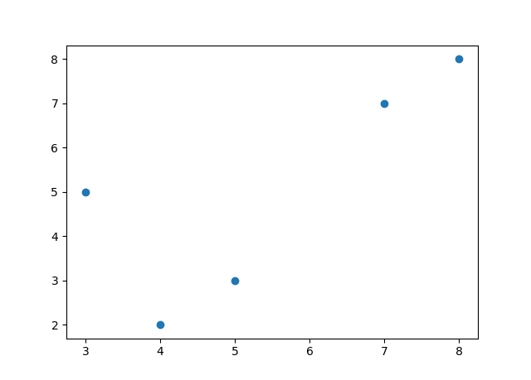
A Simple Scatter Plot using Matplotlib
So in such situations, plotting annotations can help us in understanding and explaining the data points. So first let’s plot the above figure using python without using any annotations:

import matplotlib.pyplot as plt
x = [3, 5, 7, 8, 4]
y = [5, 3, 7, 8, 2]
plt.scatter(x, y)
plt.show()

Scatter Plot without annotations
So as you can see we have plotted the figure without using annotations. Now let’s see how to annotate this graph using Python to make it self-explanatory. I will represent the data points as the monthly outcomes:

import matplotlib.pyplot as plt
x = [3, 5, 7, 8, 4]
y = [5, 3, 7, 8, 2]
labels = ["Jan", "Feb", "Mar", "April", "May"]
plt.scatter(x, y)
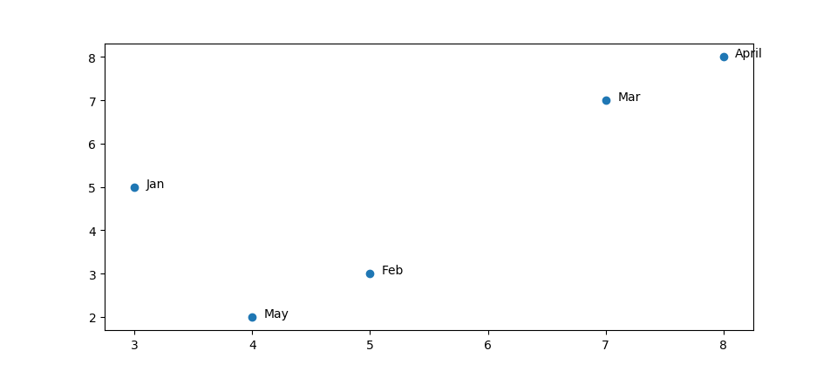
Scatter plot with annotations
So this is how we can easily annotate any kind of plot using Python. In the above code, I have just introduced a new list of labels which are annotations of the data points of the scatter plot and then I am just assigning each of the items in the list to each data point.
Summary
So using annotations can help you understand and explain data visualizations very easily. Here is a complete tutorial where you can learn more about annotating graphs using Python. I hope you liked this article on plotting annotations using Python. Feel free to ask your valuable questions in the comments section below.

